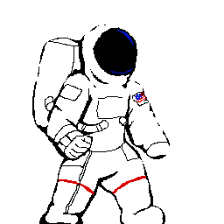

# Team Members

Alex Mathis - Programming

Bryant Aparicio - Programming

Jesus Machuca - Programming

Felicia De La Isla - Music

Jessica Ortiz - Artwork

Table of Contents

1. Genre 3

2. System Requirements 3

3. Game Goal 3

4. Gameplay 3

5. Game Mechanics 4

6. Game Story 4

7. Game Controls & User Interface 5

8. Monetization 5

9. Replayability 5

10. Sequel 6

11. Inspirations & Examples 6

12. Asset List 8

# 1. Genre

2D action adventure game

# 2. System Requirements

**OS:** Windows 7 or higher  
**Processor:** 2.4 GHz Dual Core Processor or Highter  
**Memory:** 2 GB or higher  
**Graphics:** Intel HD 4000 or equivalent  
**DirectX:** DirectX 9.0

# 3. Game Goal

Players will move through a series of levels with the primary goal being to reach the end. Various enemies will serve as obstacles for the player. Enemies can be killed by using one of the variety of weapons in the stage and each enemy will drop any weapon they are carrying when they die. This allows the player to constantly switch between different weapons as they progress through the game.

# 4. Gameplay

Our game takes place in real time in a 2D environment. Players are given a side view of the current level and can see the player moving through it. Movement is free and not restricted to tiles. Players will also possess a jetpack item that can be used for rapid vertical and horizontal movement as well as hovering. The jetpack will possess a recharging meter that prevents players from constantly using it.

Enemies using weapons will attempt to block the player’s progress through the level. Players can equip these same weapons and use them my killing the enemy holding them. Players will possess a health meter that will decrease with each instance of damage as well as a shield what will regenerate over time. Shield damage will be dealt before health damage so players will always be able to regenerate a portion of damage dealt.

Levels will also contain collectables that will increase the player's score when picked up.

# 5. Game Mechanics

Enemies will have several basic types:

Patrolling: This enemy will walk back and forth through a designated area until it encounters the player.

Guarding: This enemy will stand in a specific area until the player enters their view.

Flying: Can have behaviour similar to either flying or guarding enemies but will be able to move freely through the air.

Each enemy will be equipped with a weapon and more weapons can also be encountered through the current stage. When an enemy dies, it will drop any equipped weapon which can be picked up by the player. Weapons will include pistols, rifles, shotguns, rocket launchers, turrets, grenades, and various melee weapons. Enemies will perform different behaviours depending on their current weapon with ranged weapons causing enemies to attempt to stay within moderate distance from the player, melee weapons causing enemies to charge the player, and heavy weapons (rocket launchers, grenades) causing the enemy to maintain the maximum possible distance.

The jetpack will function by using large amounts of momentum. This approach allows players to chain their movements together with jumping and following in order to quickly traverse through a level. Certain enemies will also require its use in order to get the correct angle of attack.

# 6. Game Story

The story follows an unnamed astronaut who must go from planet to planet while searching for a habitable environment for their people. They must clear out the invading enemy force before a settlement can be established. Once they have cleared out the invading enemy force they can establish a settlement before moving on to the next world.

# 7. Game Controls & User Interface

Basic Controls

W: Jump

A: Move left

S: Duck

D: Move right

E: Pick up/Drop Weapon

Spacebar: Jump

Left Mouse Button: Use Weapon

Right Mouse Button: Use Jetpack

Movement will be done using for main keys (WASD). Players can only jump from the ground, not in the air. Shooting will be done with a mouse cursor. When the weapon button is pressed the player will shoot their current weapon in a straight line from their position to the mouse cursor.

The jetpack will propel the player with a large burst of movement in their current direction. Jetpack movement isn’t affected by cursor location, only which arrow keys are pressed. Pressing jump and jetpack at the same time will propel the player straight up. Pressing only the jetpack button while in the air will hover the player in place.

There will be three main GUI elements. The health bar, shield bar, and score. The health bar will be a red bar in the bottom left of the screen and it will track the player’s current health. The shield bar will be immediately above the health bar and it will track the player's shield health. The score will be displayed as a string of numbers in the top right of the screen

# 8. Monetization

This game will be free to play and support ads as a form of revenue.

# 9. Replayability

One of the most important features of this game’s replayability is the basic gameplay loop. Our jetpack movement system and constant weapon switching should be enjoyable enough that players will keep coming back or recommending the game to their friends. Also important is the score system. By killing enemies, not taking damage, completing levels quickly, and collecting collectables the player’s score will increase. The enjoyable gameplay will make players want to come back and try for a higher score.

# 10. Sequel

Currently there are no plans for a sequel. If this game performs well financially that can be considered however.

# 11. Inspirations & Examples

Contra

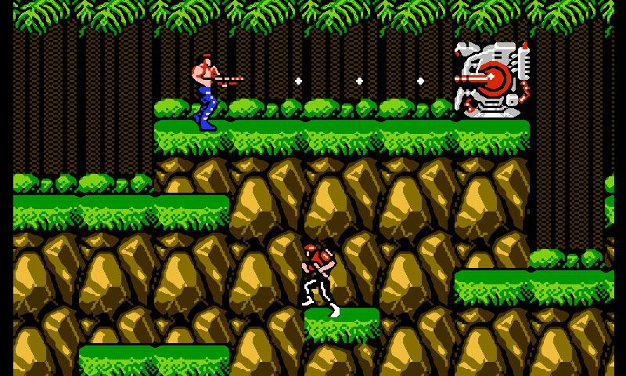

Contra’s timeless running and shooting mechanics heavily influence the design of our game. The simple yet skillful gameplay is what we are aiming for in Galaxy Conquest.

Metal Slug

[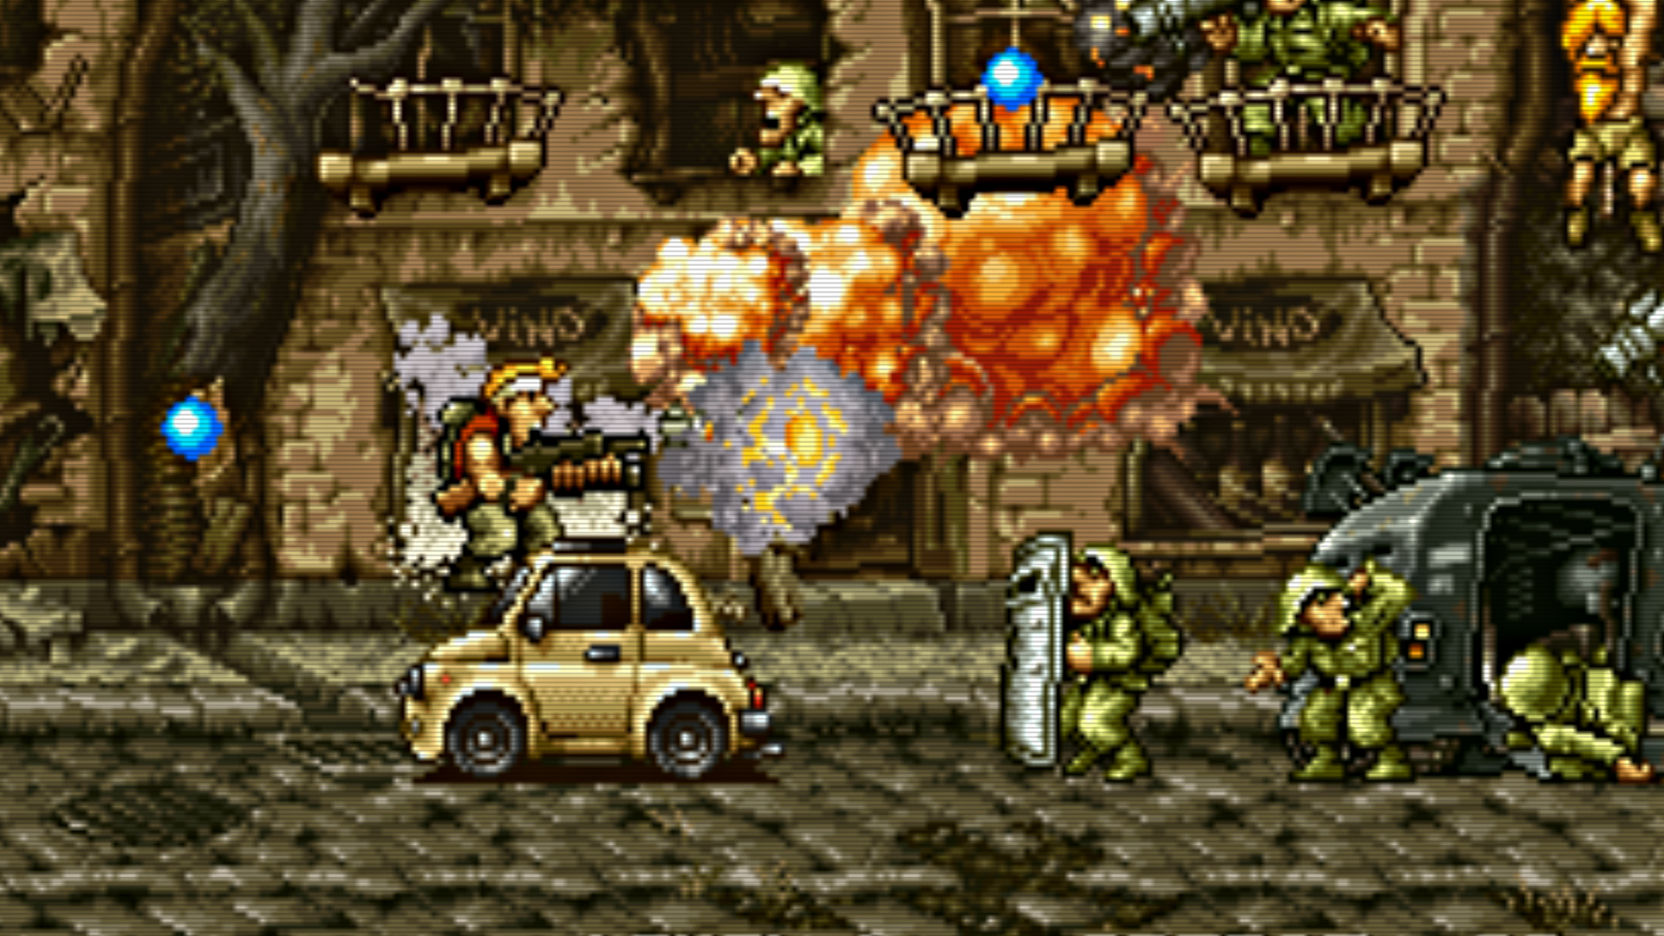](http://anguerde.com/pics/main/36/338265-metal-slug.jpg)

We are using Metal Slug as an inspiration for our gameplay due to it’s fast paced nature and wide variety of weapons. Metal Slug has always been successful due to it’s arcade-like run and gun action and we are trying to emulate that in our own game.

Metroid

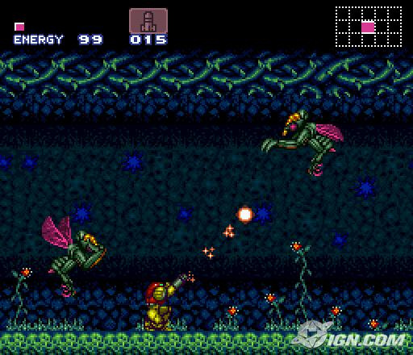

We are using environments from the metroid series as inspiration for our own game’s setting across different worlds. It’s environments have always been a hugely popular part of the franchise and so we are using them as a source for ideas in our own levels.

# 12. Asset List

Player:

Basic sprite - Jessica Ortiz

Running animation - Jessica Ortiz



Running Audio - Felicia De La Isla

Jumping Audio - Felicia De La Isla

Death audio - Felicia De La Isla

Enemies:

Enemy sprites (more is better) - Jessica Ortiz

Walking animation - Jessica Ortiz

Attacking animation - Jessica Ortiz

Death sounds - Felicia De La Isla



Weapons:

Pistol sprite - <https://opengameart.org/content/weapon-inventory-graphics>



Shotgun sprite - https://opengameart.org/content/weapon-inventory-graphics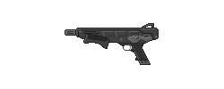

Rifle sprite - <https://opengameart.org/content/weapon-inventory-graphics>

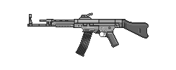

Rocket launcher sprite - <https://opengameart.org/content/rocketlauncher>

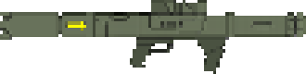

Rocket projectile sprite - <https://opengameart.org/content/missile-0>



Misc:

Level backgrounds (preferably x3) - Jessica Ortiz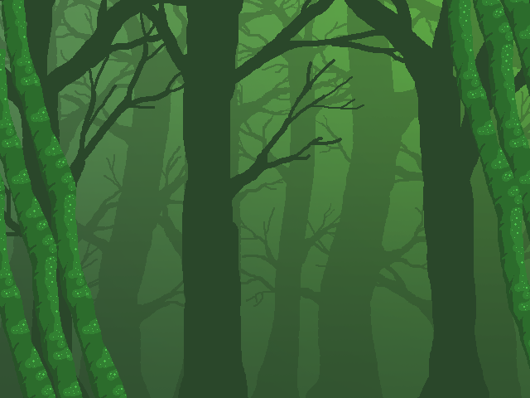

Level sprites (preferably 3, can work with less) - Jessica Ortiz and

<https://www.gamedevmarket.net/asset/free-2d-game-objects-9153/>

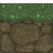

Level music (x2) - Felicia De La Isla

Health/Shield bar sprites - Jessica Ortiz

